3)console commands and multiline statements

We can execute multiline statements in console. Type a stement on one line , now instead of printing enter(which will execute this statement) press shift+enter(on windows) and command+ enter(on mac), now you can write your statement in multiline.

4)Sources, Network and other panels

In sources tab you can see al files. Some times all code is in one line. At bottom left of file, you will find icon, pretty print. Click on it to format code nicely and will make it human readable.

Network tab shows you all the assest that are loaded into page with timeline. If you have not opened it, then request wnt be shown here, it might be because of performance reasons. To see request here, open this tab and refresh the page.

Then we have performance and memory tabs. These are advances features which help us to figure out why our page might be running slow.

The we have application tab. It has info about our website. Right now I would say important things to note is that local storage and cookies are stored here. You can change the value of cookie , if you want. This can be useful if you are tracking data across web pages and you need to actually reset some of data. We can right click on web page(down cookies) and clear all cookies.

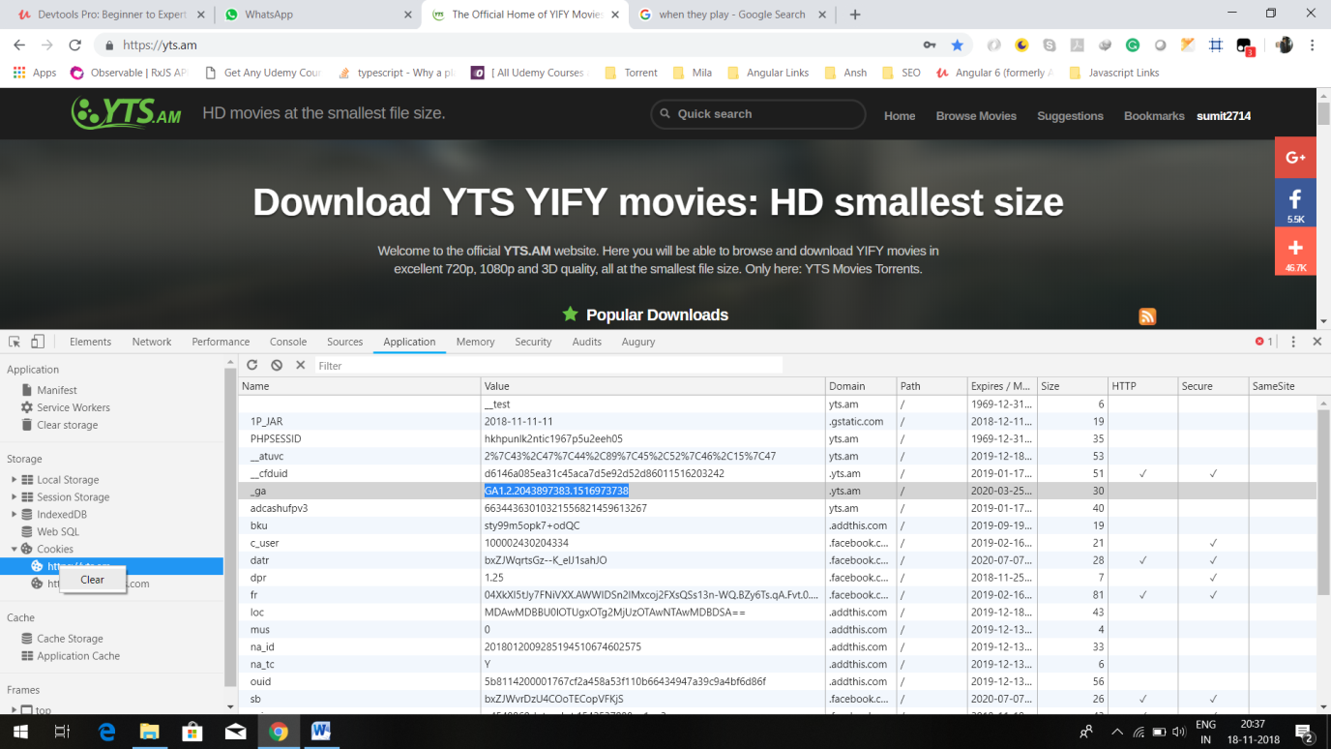

The we have security tab tells you about what type of security protocol your web page is using and helps you debug any problems with insecure scripts and then we have audit panel, which is actually a great tool to help you figure out , how to get your page page to load faster quickly. Here at bottom there is button to run audits. Whne you run audits, it give you some tips for speeding up web page.

6)viewing your changes

Lets say we want to get copy of current state of dom. In console run this-

**document.getElementsByTagName('html')**

it gives me array of elements of type html, there is really one. So lets do-

**document.getElementsByTagName('html')[0]**

now we will get object.we can open different tags and see wht they contain.

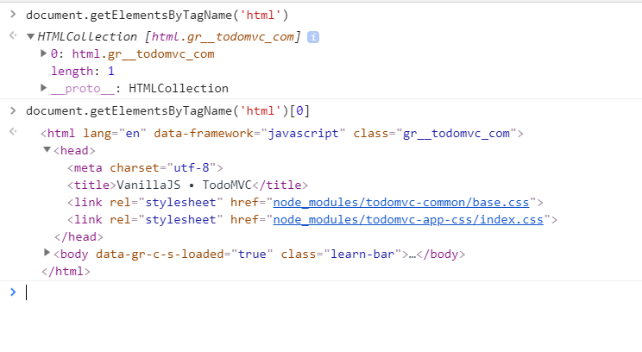

But anyway we want to get a string that actually has all this data in it. So run-

**document.getElementsByTagName('html')[0].outerHtml**

now we will get whole html of web page printed in console.this is in string version of DOM. Lets we want to have this html in our ide. How do we do it. We can copy any string in console by, running this in console-

**copy(‘sumit’)**

when we do paste in any editor we will get sumit pasted. Lets follow this logic. Run this-

**copy(document.getElementsByTagName('html')[0].outerHTML)**

now paste in ide, you will have whole html of page.

What is its use. You can made changes on the fly on dom. i.e update css, change text of html and all that. If you repeat above process, you will get updated Dom. You can compare both files(or strings) using some online difference tool or some windows tool. This is really ging to help us out when we are doing workflow and we have files on server that we need to actually port these changes over into actual code. **Meld difference**  is desktop app that do the same. It hows diffrences like that-

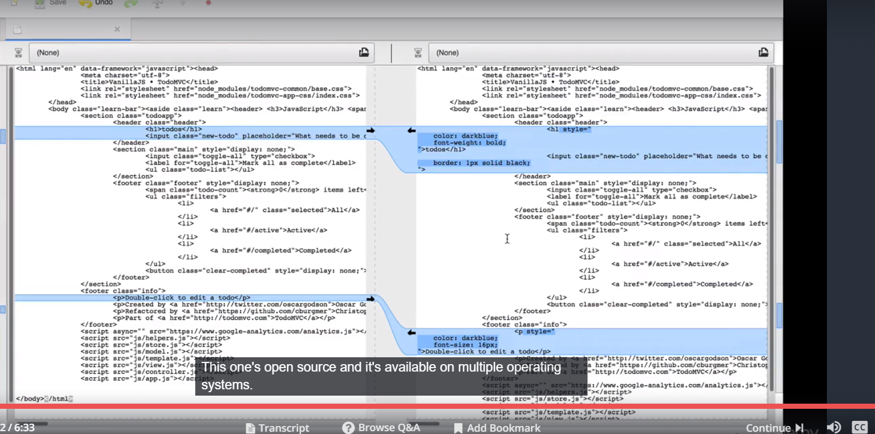

It is useful tool(meld).